Insruction made by Aaron Pope. If you have trouble understanding them email me at awpope@ncsu.edu

Steps to run phase plane 7 on matlab

1)download pplane7.m into your home unity directory. It should be something like /afs/unity.ncsu.edu/users/(((((((first letter of your unity name)))/unityname

the unityname is your unity name ex for me its /afs/unity.ncsu.edu/users/a/awpope

- open up matlab. On the linux machines you go to the applications tab on the top bar. Then go to NCSU realm. Then NCSU applications. Then MATLAB.

- Once matlab has open go to file then open. Make sure you can see pplane7.m in your home directory. Do not open it just make sure its there.
- In the command window type in pplane7

5)you should see a window open like this

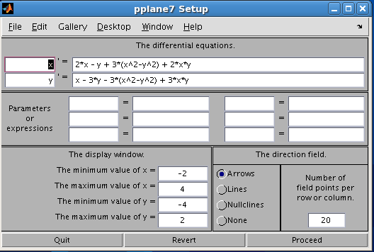
5)when you plug in your differential equations they must be first order that is must be in the form of dx/dt , dy/dt or x', y'.
6) once the equations are plugged in make sure your minimum and maximum value of x and y are large enough to include the point you would like your solution to appeared at. Then click proceed. You should see something like this
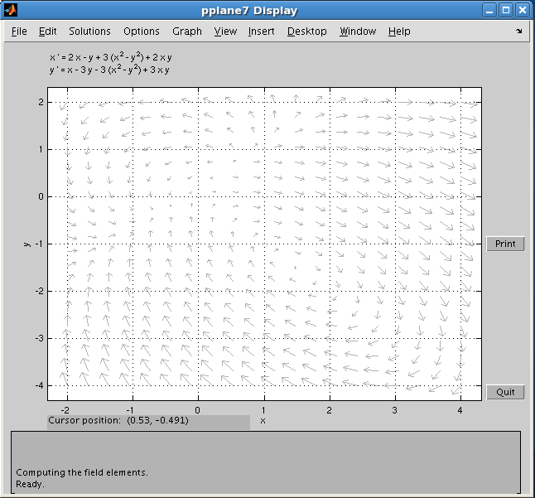
7) Then for you point solution hover your mouse over the point you want. You should see the cursor position at the bottom of the graph. Then click your point and a solution will pop up like this.

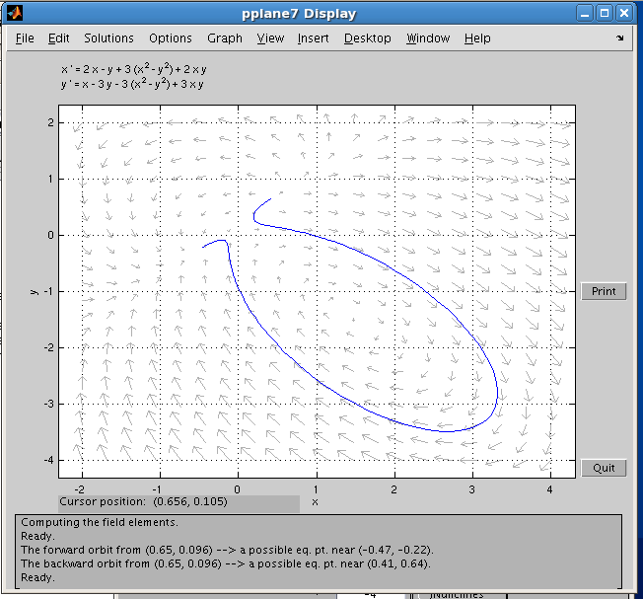

For this particular solution the given point was (.656, .105) which just so happens to be the same thing as the cursor position.

